PICTURE | ENGLISH | ITALY | AUSTRIA | BULGARIA | FINLAND | FRANCE | GREECE | LITHUANIA | POLAND | TURKEY
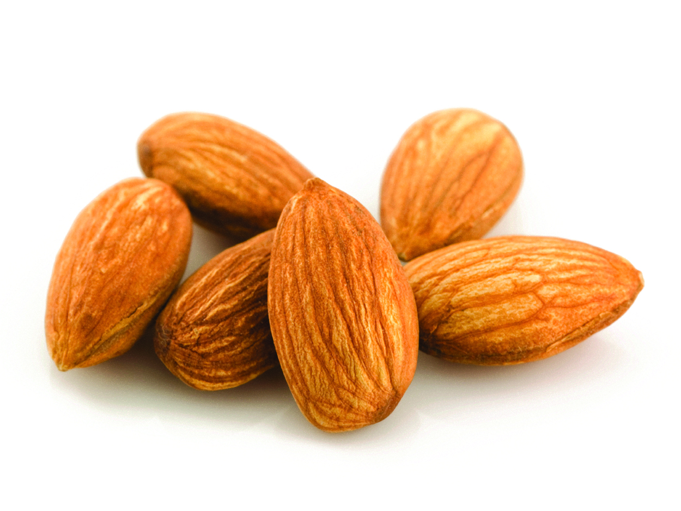 | Almond | Mandorla | Mandel | бадем | manteli | amande | αμύγδαλο | Migdolas | Migdaly | Badem
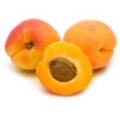 | Apricot | Albicocca | Aprikose | кайсия | aprikoosi | abricot | βερίκοκο | Abrikosas | Morela | Kayısı
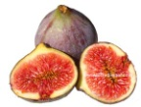 | Figue | Fico | Feigen | смокиня | viikuna | figue | σύκο | Figa | Figa | İncir
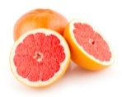 | Grapefruit | Pompelmo | Grapefruit | грейпруфт | greippi | pamplemousse | γκρέιπ φρουπ | Greipfrutas | Grejfrut | Greyfurt
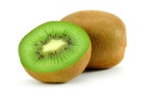 | Kiwi | Kiwi | Kiwi | киви | kiivihedelmä | kiwi | ακτινίδιο | Kivis | Kiwi | Kivi
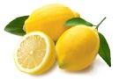 | Lemon | Limone | Zitrone | лимон | sitruuna | citron | λεμόνι | Citrina | Cytryna | Limon
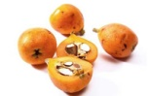 | Medlar | Nespola | Mispel | мушмула | mispeli | nèfle | μούσμουλο | Šliandra | Niesplik | Muşmula
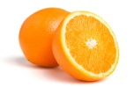 | Orange | Arancia | Orange | портокал | appelsiini | orange | πορτοκάλι | Apelsinas | Pomarancza | Portakal
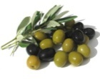 | Olive | Oliva | Olive | маслина | oliivi | olive | ελιά | Alyvuogė | Oliwka | Zeytin
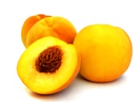 | Peach | Pesca | Pfirsich | праскова | persikka | pêche | ροδάκινο | Persikas | Brzoskwinia | Şeftali
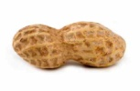 | Peanut | Nocciolina | Erdnuss | фъстък | pähkinä | cacahuète | φυστίκι | Žemės riešutas | Orzech ziemny | Fıstık
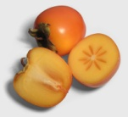 | Persimmon | Caco | Kaki | японско дърво | persikka | kaki | λωτός | Persimonas | Kaki | Trabzon Hurması
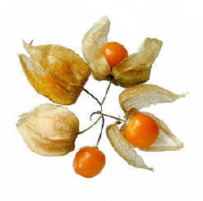 | physalis | Physalis | Physalis | рожкови |  | physalis | φυσαλίς | Fizalis | Pecherzyca | Yer Kirazı

