PICTURE | ENGLISH | ITALY | AUSTRIA | BULGARIA | FINLAND | FRANCE | GREECE | LITHUANIA | POLAND | TURKEY
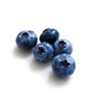 | Blueberry | Mirtillo | Heidelbeere | боровинка | mustikka | myrtille | είδος μούρου | Mėlynė | Jagoda | Yabanmersini
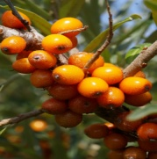 | Buckthorn | Spincervino | Sanddorn | трънка | tyrni | argousier | ιπποφαές | Šaltalankis | Szaklak | Cehri
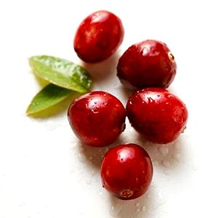 | Creanberry | Mirtillo rosso | Preiselbeere | червена боровинка | karpalo | canneberge | κράνo | Spanguolė | Zurawina | Kızılcık
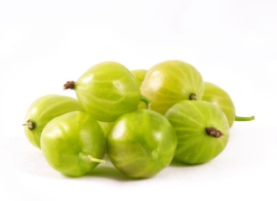 | Gooseberry | Uva spina | Stachelbeere | цариградско грозде | karviaismarja | groseilles à maquereau | φραγκοστάφυλο | Agrastas | Agrest | Bektaşi üzümü
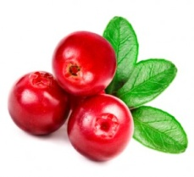 | Lingon berry |  |  | екзотични зрънца | puolukka |  | είδος μούρου | Bruknė | Borowka
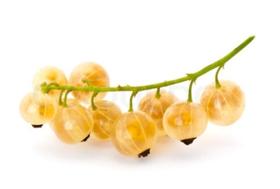 | Yellow currant | Ribes giallo | gelbe Johannisbeeren | жълт касис | keltainen herukka | raisin blond | κίτρινη σταφίδα | Geltonieji serbentai | Biala porzeczka | Kuş üzümü

